Exercise 1

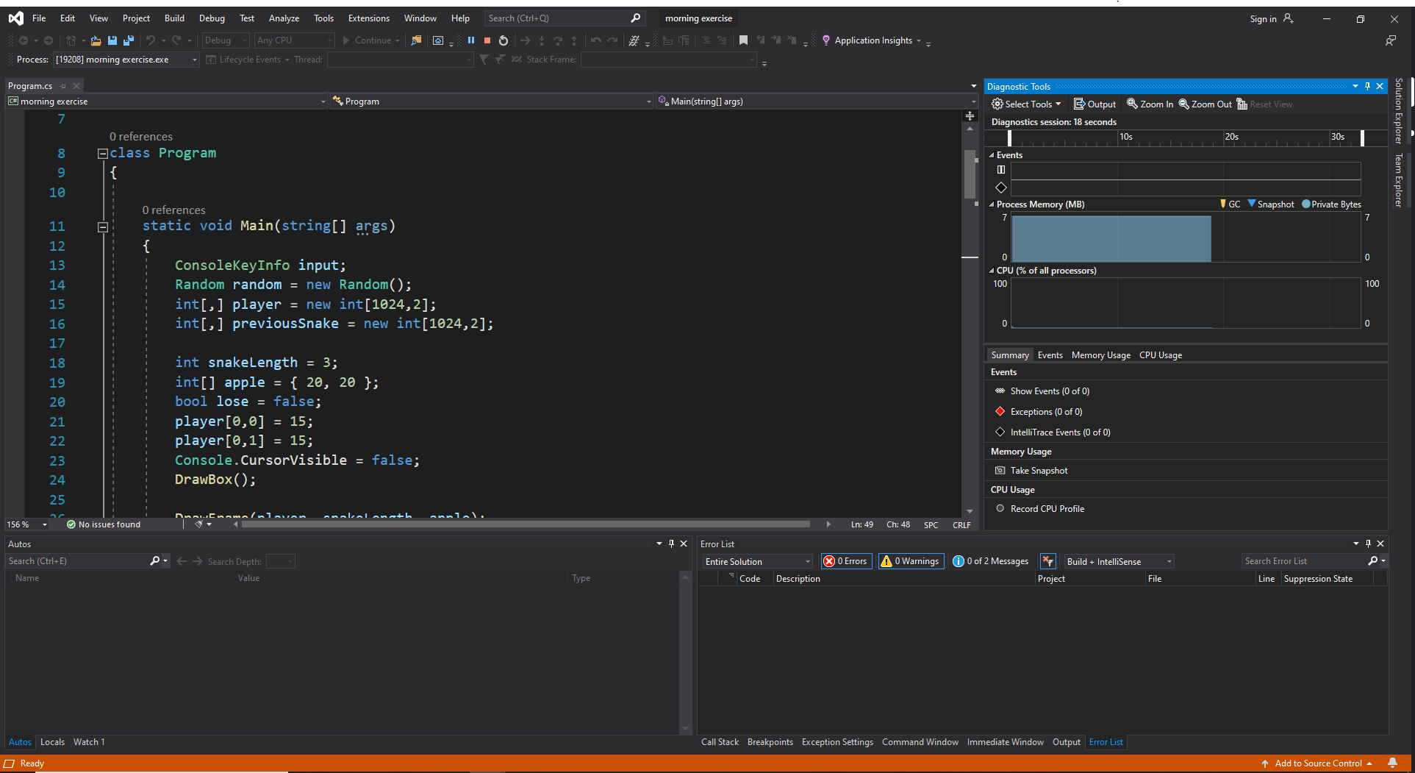

Exercise 2



This error occurred because the type Random was misspelled. Because there is no type “Randon” there is a compile error because it cannot find the non-existent type.



This error was caused by a semicolon being omitted from the end of line 18. The semi colon is there so the compiler knows where the end of the line is and it can’t work if there isn’t semicolons so it causes a compile error instead.



This error was cased by assigning a number with the wrong type to a variable. On line 19 a variable with type int was initialized but the value assigned to it was a double which isn’t possible. This can be fixed by assigning a value that doesn’t have decimal places or initialising the variable as a double.

Exercise 3

I use stack exchange to help me understand C# and when I need to remember something. Although not all the information there is accurate, if you look through all the relevant answers you can often find the information you are looking for.

Exercise 4

